Microsoft Dynamics NAV 2015 integration with Compello

Implementation Guidelines

Prepared by: Tomas Stankevičius

Reviewed by:

Version: 1.01

Date: 2014-07-23

Modified by: Martynas Butrimanskas

Revision date:

Date: 2016-01-29

Modified by: Jón Fjölnir Albertsson

Revision date:

Table of Contents

Introduction 3

Requirements 3

Installation steps 3

Import new objects 3

Change functionality in standard objects 3

Codeunit 408 DimensionManagement 4

Codeunit 5150 Integration Management 6

Setup integration 8

Integration to Compello Setup 8

Field Mapping Setup 9

Integration Table Setup 9

User Notification 11

NAS setup 11

Menu 12

Administration menu 12

User menu 13

Limitations 13

Annex A – New objects 14

Annex B – Standard customized objects 16

Process 16

Issues 21

# Introduction

In this document you can find instruction on how to implement Microsoft Dynamics NAV 2013 R2 integration with Compello in customer database where there are already customizations.

One of the issues while implementing this solution can be caused by objects which IDs already used by customer. In this case renumbering of integration objects required (usually it takes less time than renumbering of customer solution).

Product is ready to be used with Windows Client and Web Client.

# Requirements

To implement this solution customer needs to have free objects within their Microsoft Dynamics NAV license:

* 16 Tables
* 1 Report
* 7 Codeunits
* 3 XML Ports
* 1 Menu Suite
* 21 Pages

# Installation steps

## Import new objects

First step is to import new objects. As mention before there can be a need to renumber objects before import. If customer already uses objects with same IDs you need to renumber objects and only then import.

When importing file import only objects that will be “Created”.

List of all new objects presented in Annex 1.

## Change functionality in standard objects

Functionality mentioned in this section can be merged into current solution by using different tools allowing merging one solution into another. In this section you can find detailed instructions on what was changed in standard objects.

List of all changed standard objects presented in Annex 2.

### Codeunit 408 DimensionManagement

#### Create new Functions/Triggers

**PROCEDURE AddDimToDimSet@35(VAR DimSetID@1000 : Integer;DimCode@1001 : Code[20];DimValue@1003 : Code[20]) : Boolean;**

VAR

DimVal@1002 : Record 349;

TempDimSetEntry@1004 : TEMPORARY Record 480;

BEGIN

//CMP001 Function created

IF DimValue <> '' THEN BEGIN

IF NOT DimVal.GET(DimCode, DimValue) THEN BEGIN

EXIT(FALSE);

END;

END;

GetDimensionSet(TempDimSetEntry, DimSetID);

IF TempDimSetEntry.GET(DimSetID, DimCode) THEN BEGIN

IF TempDimSetEntry."Dimension Value Code" <> DimValue THEN BEGIN

TempDimSetEntry.DELETE;

END ELSE BEGIN

EXIT(TRUE);

END;

END;

IF DimValue <> '' THEN BEGIN

TempDimSetEntry."Dimension Set ID" := DimSetID;

TempDimSetEntry."Dimension Code" := DimVal."Dimension Code";

TempDimSetEntry."Dimension Value Code" := DimVal.Code;

TempDimSetEntry."Dimension Value ID" := DimVal."Dimension Value ID";

TempDimSetEntry.INSERT;

END;

DimSetID := GetDimensionSetID(TempDimSetEntry);

EXIT(TRUE);

END;

**PROCEDURE CopyDimSetToDimSet@37(FromDimSetID@1000 : Integer;ToDimSetID@1001 : Integer) ResultDimSetID : Integer;**

VAR

TempDimSetEntry@1002 : TEMPORARY Record 480;

TempDimSetEntry2@1003 : TEMPORARY Record 480;

BEGIN

//CMP001 Function created

IF FromDimSetID = 0 THEN BEGIN

EXIT(ToDimSetID);

END;

IF ToDimSetID = 0 THEN BEGIN

EXIT(FromDimSetID);

END;

GetDimensionSet(TempDimSetEntry, FromDimSetID);

GetDimensionSet(TempDimSetEntry2, ToDimSetID);

IF TempDimSetEntry.FINDSET THEN BEGIN

REPEAT

IF TempDimSetEntry2.GET(ToDimSetID, TempDimSetEntry."Dimension Code") THEN BEGIN

TempDimSetEntry2."Dimension Value Code" := TempDimSetEntry."Dimension Value Code";

TempDimSetEntry2."Dimension Value ID" := TempDimSetEntry."Dimension Value ID";

TempDimSetEntry2.MODIFY;

END ELSE BEGIN

TempDimSetEntry2."Dimension Set ID" := ToDimSetID;

TempDimSetEntry2."Dimension Code" := TempDimSetEntry."Dimension Code";

TempDimSetEntry2."Dimension Value Code" := TempDimSetEntry."Dimension Value Code";

TempDimSetEntry2."Dimension Value ID" := TempDimSetEntry."Dimension Value ID";

TempDimSetEntry2.INSERT;

END;

UNTIL TempDimSetEntry.NEXT = 0;

END;

ResultDimSetID := GetDimensionSetID(TempDimSetEntry2);

END;

### Codeunit 5150 Integration Management

#### Create new Global variable

CompelloIntegrMgt : Codeunit 70000;

#### Change code in functions:

**PROCEDURE GetDatabaseTableTriggerSetup()**

*Add code*

IF COMPANYNAME = '' THEN

EXIT;

//CMP001 Start

IF CompelloIntegrMgt.IsIntegrationRecord(TableID) THEN BEGIN

Insert := TRUE;

Modify := TRUE;

Delete := TRUE;

Rename := TRUE;

EXIT;

END;

//CMP001 End

IF NOT GetIntegrationActivated THEN

EXIT;

**PROCEDURE OnDatabaseInsert()**

*Add code*

//CMP001 Start

CompelloIntegrMgt.OnDatabaseInsert(RecRef);

//CMP001 End

IF NOT GetIntegrationActivated THEN

EXIT;

**PROCEDURE OnDatabaseModify()**

*Add code*

//CMP001 Start

CompelloIntegrMgt.OnDatabaseModify(RecRef);

//CMP001 End

IF NOT GetIntegrationActivated THEN

EXIT;

**PROCEDURE OnDatabaseDelete()**

*Add code*

//CMP001 Start

CompelloIntegrMgt.OnDatabaseDelete(RecRef);

//CMP001 End

IF NOT GetIntegrationActivated THEN

EXIT;

**PROCEDURE OnDatabaseRename()**

*Add code*

//CMP001 Start

CompelloIntegrMgt.OnDatabaseRename(RecRef, XRecRef);

//CMP001 End

IF NOT GetIntegrationActivated THEN

EXIT;

## Setup integration

### Integration to Compello Setup

At first general integration setup should be filled. It can be accessed at “Departments 🡪 Administration 🡪 Application Setup 🡪 Compello Integration 🡪 Integration To Compello Setup”.

|  |  |
| --- | --- |
| Field Name | Description |
| Max. No. of Tries | Maximum number of tries to synchronize changed record to Compello. 0 means unlimited. In case application will not succeed to send data it will mark it as an error. |
| Max No. of Rec. per Transact. | Maximum number of records to send as one batch while updating records in Compello. It is useful in case there are big batches running and changing master data that should be sent to Compello. 0 means unlimited. |
| Integr. Table Nos. | No. series for integration table setup described in section “Integration Table Setup”. Default is COMPOBJ. |
| Web Service Address | Address of web service where information about changed records should be sent as well documents should be taken. Example (http://compellosql/invoiceapproval/). |
| Customer ID | Customer ID in Compello. This is the name of the configuration file without file extension (dbinf). |
| User Name | User name to use when call Compello web service |
| Password | Password to use when call Compello web service |
| Client ID | Client ID in Compello. For example SI. |
| URL for Export Log | URL which will be used if error of exporting data to Compello occurs. It is regular link which allows to open Page in Microsoft Dynamics NAV. Example of such is “dynamicsnav://localhost:7046/dynamicsnav71/CRONUS International Ltd./runpage?page=70001” |
| Doc. Type Item Invoice | The Compello Voucher Type for Item Purchase Invoice. Is default IVF (Innkjøp Vare Faktura). |
| Doc. Type Item Credit | The Compello Voucher Type for Item Purchase Credit Memo. Is default IVK (Innkjøp Vare Kreditnota). |
| Doc. Type Journal Invoice | The integration creates journal lines for invoice with this type (Voucher type in Compello). They are created in the journal that is defined in this setup. The default value is IF (Innkjøp Faktura). |
| Doc. Type Journal Credit | The integration creates journal lines for credit memo with this type (Voucher type in Compello). They are created in the journal that is defined in this setup. The default value is IK (Innkjøp Kreditnota). |
| Journal Template | The name of the Journal Template in NAV. The default value is INNKJØP. |
| Journal Batch | The name of the Journal Batch in NAV. The integration creates documents of the types defined in the fields “Doc. Type Journal Invoice” and “Doc. Type Journal Credit”, in this journal instead of as Purchase Invoices. The default value is COMPELLO. |
| XLS File Path | Full file path for the XLS converter, that Compello is depending on to convert the XML file to their own format. Example “C:\temp\Order2Compello.xsl”. |
| Image File Stylesheet | Full file path for the Stylesheet, that Compello is depending on to convert the XML file to image. Example “C:\temp\CompelloOrderView.xslt”. |
| XML Folder Archive | The folder where the XML files are archiving. Example “C:\temp\History\” |
| Doc. Type Purchase Order | The Voucher Type written in the XML files for Receipts. Default value is IO (Innkjøp Ordre). |
| Scanner Doc. Type Purchase Order | The Scanner Series Type written in the XML files for Receipts. Example IB. |
| Default PO Account | The G/L account that the Purchase Order should be booked on. Example 4010. |
| Authentication Code | Controls if receipt line is imported as authenticated (A) or not authenticated (N). |
| Default Free VAT Code | Used when Purchase Lines are created and the imported Tax Code is without value from Compello. The Tax Code must be setup with 0 %. |

### Field Mapping Setup

Field mapping setup is used to relate Microsoft Dynamics NAV intermediate table structure to the integration component (dll). It can be accessed at “Departments 🡪 Administration 🡪 Application Setup 🡪 Compello Integration 🡪 Compello Map-to Fields”.

|  |  |
| --- | --- |
| Field Name | Description |
| Code | Unique code to separate records. Recommended to use some letters and numbers like “E001_00”. In this example, E stands for Export. 001 for the first table. _00 for showing that this is the table. The first field for this table would then have the code E001_01. |
| Name | Short name to identify to which parameter in integration library it is related like “Supplier” |
| Data Type | Fixed number for application to identify which actions should be used. This is an integer value and is unique for a table and all fields belonging to that table. |
| Field No. | Field number of Microsoft Dynamics NAV intermediate table. “Zero” means that it is for the header to set which “map-to fields” can be used while setting lines. The field number must match the field number in the “Compello Import Header“ (table 70008) or “Compello Import Line” (table 70009) tables. When importing documents from Compello this value is used to map field value. |
| Table Type | This is used to define that some values from document line imported from Compello should be placed in Microsoft Dynamics NAV document header (select “Header” as a value). In other cases, this value should be blank. The document header is imported as line in the “Compello Import Line” table. |

Field mapping setup can be imported and exported from xml file called “Import Map-To Fields.xml”. This can be done by Clicking button “Import Map-to Fields” in “Map-to Fields” list.

### Integration Table Setup

To set which tables data should be sent to Compello and which should be received, documents data configuration is managed in “Integration Table Setup”. It can be accessed at “Departments 🡪 Administration 🡪 Application Setup 🡪 Compello Integration 🡪 Compello Integr. Table List”. If you would like to edit you need to go to the Card by pressing “Edit” or double click on a record.

Header (General FastTab)

|  |  |
| --- | --- |
| Field Name | Description |
| Code | Unique code to separate records. If you set number series in “Integr. Table Nos.” in Integration Setup than it will work as defined in that number series (like in all other parts of Microsoft Dynamics NAV application) |
| Table ID | Table which you would like to synchronize |
| Synchronize | How it should be synchronized:   * None – will not be synchronized. Can be used to prepare template that customers can later activate. * Manual – Synchronization should be managed manually by using “Integration Change Log” and “Import Log” pages * NAS – Synchronization will be managed by Microsoft Dynamics NAV NAS Service. Additional setup is needed (described in section “NAS setup”) * On-Line – Record will be synchronized on change. Recommendation is to set this only for data which changes very rarely like Dimensions or Salespersons and avoid setting this for Vendors and similar information. |
| Map-to Table | Select record from “Map-to Fields” |
| Action IO | Import or Export message |
| Related to Header | This field is used only for purchase lines to link to purchase header |
| Dimension Code | This field is used only when setting Dimensions for export. It is to define which dimension should be synchronized |
| Dimension No | The “Shortcut dimension number” from the general ledger setup. When updating the dimension this value is used to fetch the dimension code. |
| Credit Note | This field is only used for purchase document to separate credit memo from invoice |

Header (Filters FastTab)

|  |  |
| --- | --- |
| Field Name | Description |
| Filter Field 1 | Field ID for which you would like to add a filter |
| Filter Value 1 | Filter value as text for “Filter Field 1” field. |
| Filter Field 2 | Field ID for which you would like to add a filter |
| Filter Value 2 | Filter value as text for “Filter Field 2” field. |
| Filter Field 3 | Field ID for which you would like to add a filter |
| Filter Value 3 | Filter value as text for “Filter Field 3” field. |

Note: Entries that meets filters will be transferred to Compello system as InActive=FALSE. Entries that will not meet filters will be transferred to Compello system as InActive=TRUE. The filter applies to the value of the field in the “Compello Change Log” table (70001).

Lines

|  |  |
| --- | --- |
| Field Name | Description |
| Map-to Field | Select record from “Map-to Fields” |
| Field ID | Field ID of table selected in a header. Some fields are related to another table. It is only for documents when setting information coming as lines which should be migrated to header. When you import data this field can be 0 in case you would like to put some specific data like “Document Type” or any other. |
| Dimension Code | If this field value is related to dimension than you should select which dimension value it is |
| Sequence No. | Sequence on how values will be inserted into Microsoft Dynamics NAV table. It is very important to set right sequence as validation of some fields may change others and you can get unexpected result. Like if in Purchase line you modify Description first and then validate G/L Account number than description will be overwritten from G/L Account. |
| Validate | Mark if “OnValidate” trigger of field should be called. |
| Use Default Value | In case you would like to put some default data in a field (like Document Type) then fill this field. However, notice that then the system will ignore the value in the imported document field. |
| Only if not blank | When checked the value is not be mapped if the value of the imported line is blank. Blank value is defined following: Text and Code is ‘’, Option, Integer and Decimal is 0 (Zero). |

When setting Document line (for import) you should also setup integration between header and line. First of all you should set “Related to Header” field and then click on “Relation to Header” button which will open table relation setup. In this setup you should link all primary key fields from header table to a line table like presented in an example bellow.

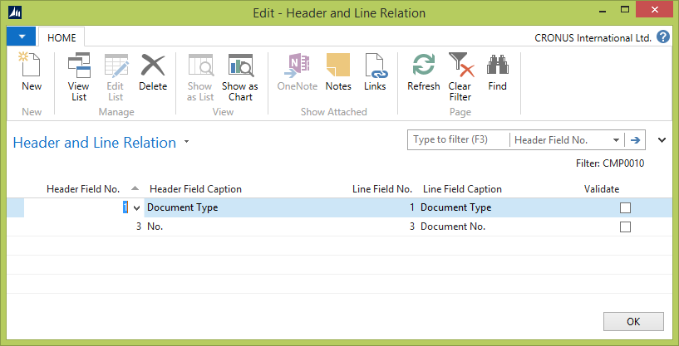

### User Notification

There is also setup for User notification. It is used to set users who should see notification in “My Notes” list when error for integration occurs. Recommended to set administrator account for notifications.

You can also use function “Export Existing Records” which will create records for synchronization of all records existing in table you set. Usually it is used when you want to synchronize table records for the first time.

### NAS setup

In case you would like records to be synchronized automatically you should setup NAS Service for Microsoft Dynamics NAV. To make it working standard Job Queue functionality should be used. Setup Codeunit 70008 “NAS - Integr. With Compello” to run by using Job Queue.

#### Job Queue Setup

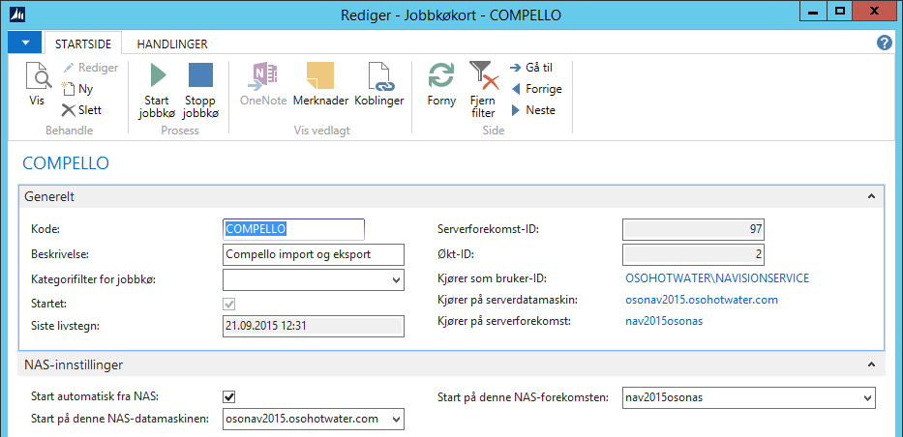

#### Job Queue Entries

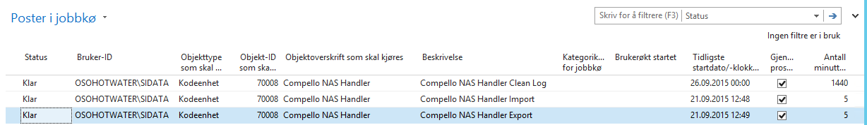

# Menu

## Administration menu

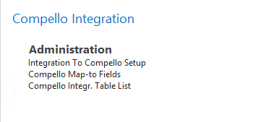

## User menu

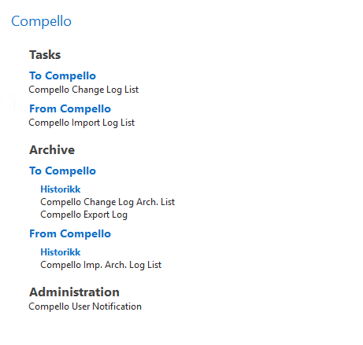

# Limitations

There are known limitation in integration between Microsoft Dynamics NAV and Compello Document management applications:

* Comments import. Microsoft Dynamics NAV limits text field size to 250 symbols which does not allow to store 2000 symbols which can be provided by integration library. As well, usually in NAV there is a separate table for comments management.
* Period management. In standard Microsoft Dynamics NAV there is only one date for a document while in Compello there can be multiple dates for the same document.

All limitations can be solved with additional design on how limitation can be solved and development of additional functionality.

# Annex A – New objects

|  |  |  |
| --- | --- | --- |
| Type | ID | Name |
| Table | 70000 | Integration To Compello Setup |
| Table | 70001 | Compello Change Log |
| Table | 70002 | Compello Change Log Archive |
| Table | 70003 | Compello Integr. Table |
| Table | 70004 | Compello Integr. Table Field |
| Table | 70005 | Map-to Fields |
| Table | 70006 | Compello Export Log |
| Table | 70007 | Compello User Notification |
| Table | 70008 | Compello Import Header |
| Table | 70009 | Compello Import Line |
| Table | 70010 | Compello RC Cue |
| Table | 70011 | Compello Import Header Archive |
| Table | 70012 | Compello Import Line Archive |
| Table | 70013 | Header and Line Relation |
| Table | 70014 | Compello Import Comment |
| Table | 70015 | Compello Import Comment Arch. |
| Report | 70000 | Export Table Data to Compello |
| Codeunit | 70000 | Compello Integr. Log Mgt. |
| Codeunit | 70001 | Compello Integr. Export Mgt. |
| Codeunit | 70002 | Compello Integr. Import Mgt. |
| Codeunit | 70003 | Compello Create Document |
| Codeunit | 70004 | NAS - Integr. With Compello |
| Codeunit | 70005 | Compello Management |
| Codeunit | 70006 | Compello Show Document |
| XML Port | 70000 | Import Map-To Fields |
| XML Port | 70001 | Import Integration Tables |
| XML Port | 70002 | Export Receipt to Compello |
| MenuSuite | 1052 | Compello Integration |
| Page | 70000 | Compello Integr. Role Center |
| Page | 70001 | Compello Change Log List |
| Page | 70002 | Compello Integr. Table List |
| Page | 70003 | Compello Integr. Table Card |
| Page | 70004 | Compello Integr. Table Subpage |
| Page | 70005 | Compello Map-to Fields |
| Page | 70006 | Field List For Integration |
| Page | 70007 | Compello Change Log Arch. List |
| Page | 70008 | Compello Export Log |
| Page | 70009 | Compello User Notification |
| Page | 70010 | Integration To Compello Setup |
| Page | 70011 | Compello Import Activities |
| Page | 70012 | Compello Export Activities |
| Page | 70013 | Compello Import Log List |
| Page | 70014 | Compello Integration Log Card |
| Page | 70015 | Compello Integration Subpage |
| Page | 70016 | Compello Imp. Arch. Log List |
| Page | 70017 | Compello Integr. Arch Log Card |
| Page | 70018 | Compello Integ. Arch. Subpage |
| Page | 70019 | Header and Line Relation |
| Page | 70020 | Compello Change Log List Del |

# Annex B – Standard customized objects

|  |  |  |
| --- | --- | --- |
| Type | ID | Name |
| Codeunit | 408 | DimensionManagement |
| Codeunit | 5150 | Integration Management |

# Process

1. Purchase Order in NAV.
   1. Posting Receipt in NAV creates Purchase Order in Compello.
   2. Invoice created in Compello from the Purchase Order.
   3. When the Invoice is set to Posted (Regnsskapsført) then the Purchase Invoice is created in NAV.
      1. Check different currency. For example Vendor defined with currency GBP in NAV and Compello invoice in USD.
      2. Decimal round off (Øreavrunding) in currency.
      3. Invoice line with different VAT types and without VAT.
      4. Set Due date (User parameter in Compello NAV integration setup).
2. Where to enable Show Compello Document.
   1. Page 20.
   2. Page 51
   3. Page 254
   4. Page 256
   5. Page 29
3. Update dimension code from dimension number on Compello Integration Table references.
   1. Integration Table List.
   2. Integration Table Card.

Compello menyen finnes under Avdelinger Compello

**Avdelinger**

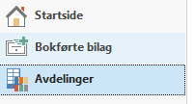

**Compello**

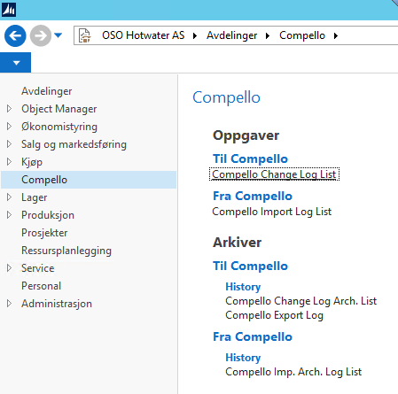

Til å sende informasjon (register data eller mottak) til Compello velg «Compello Change Log List».

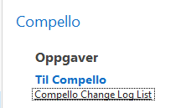

Da vises dette skjermbilde.

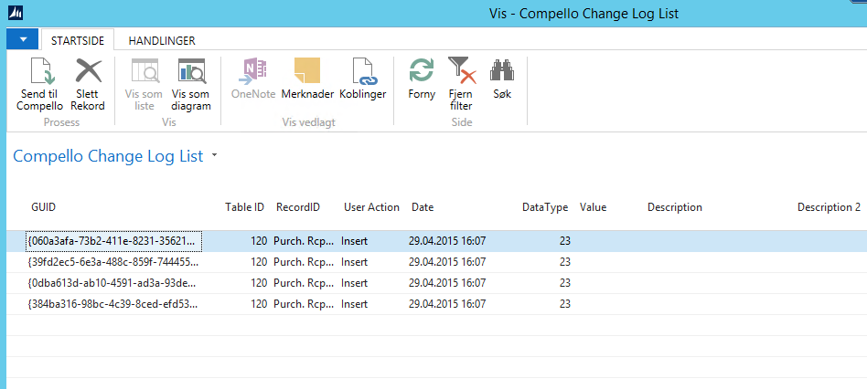

Velg «Send til Compello». Da kan du velge å sende en linje eller alle linjene (Velg alle). Da blir dataene overført til Compello.

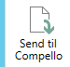

Til å hente bilag fra Compello velg «Compello Import Log List» fra Compello menyen.

cid:image006.png@01D08297.BB245F20

Da vises dette skjermbildet.

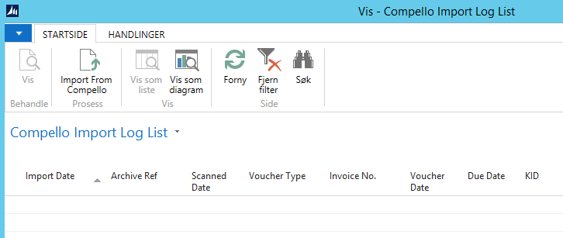

Velg «Import From Compello» da henter systemet alle linjer som har blitt satt til «Regnskapsført» i Compello.

Dobbel klikk på en av de importerte linjene.

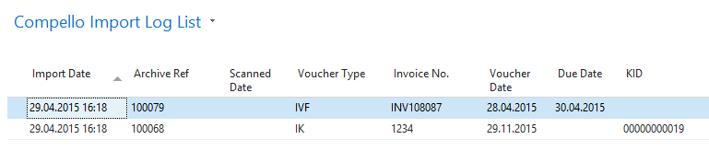

og velg siden «Create Document». Da blir Kjøpsfaktura lagd for bilagstypene (VK og VF) men bilagstypene (IF og IK) blir overført i kjøpskladd (Compello).

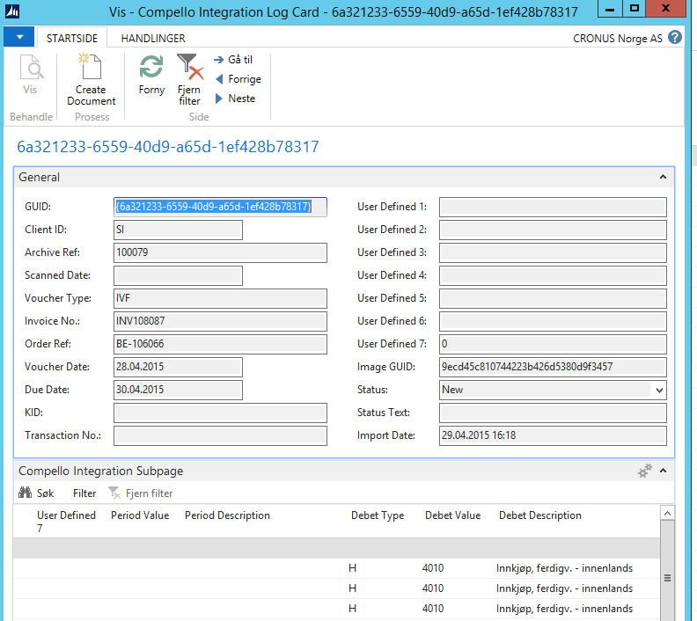

# Issues

1. ScannerSeries og VoucherType må bli satt opp I Order2Compello filen.
2. Hvordan registreres beløp med og uten moms/momskode og bilagstype?
   1. IF og IK er brutto inkludert moms.
   2. IVF og IVK er netto uten moms.
3. Setup new menu suite for Compello with logical order on items.
4. New Compello user is si-data without password.
5. Registered data in Compello are set to Inactive when updating register. Update, Modify, Delete, Rename.
   1. When there is no records after applying the filter the record is manually set to inactive.
6. Filter on mapping of integration tables. Use English value in filter string (Yes,No,Posting..).
7. InventTransID kan ikke ha verdien «1».
8. Overview of used Compello «UserDef» fields.

|  |  |  |  |  |
| --- | --- | --- | --- | --- |
| **XML out** | **Converter** | **Import NAV** | **Overview** | **Description** |
|  | 2 |  | 2 | ItemNumber |
|  | 5 |  | 5 | DiscPercent |
|  | 6 |  | 6 | InventTransId |
|  |  | 7 | 7 | Posting Date |
| 8 |  |  | 8 | ReceiptLine."Document No." |
| 9 |  |  | 9 | Purchase Header"."Vendor Shipment No. |
| 10 | 10 |  | 10 | LineNum |
| 11 |  |  | 11 | Purchase Line::Vendor Item No. |
| 12 |  |  | 12 | ReceiptLine."Posting Date" |
| 13 |  |  | 13 | Purchase Line::Location Code |
|  |  | 14 | 14 | Currency Factor |
| 15 |  |  | 15 | ReceiptLine."Line No." |
|  |  |  |  | DeliveryDate |

1. Det er viktig at dere legger inn en sjekk i integrasjonen når det gjelder fakturaer som ikke kommer over. Dette for å slippe at det er fakturaer som evt sperrer for overføring. Det som kan skje er at fakturaer ligger med en slags mellomlagringsstatus, dvs X i VO_Status_export i Search Index tabellen. Fakturaer med denne status må reaktiveres